Pictometry ArcIMS Integration Example
Installation and Configuration

Overview
This document describes the Pictometry ArcIMS Integration Example. The example is a set of web pages that shows how Pictometry images can be found using ESRI ArcIMS and then viewed using Internet Explorer.

This example can be used almost as-is with just a little site specific configuration. In addition, a web designer could customize this example by modifying the HTML and JavaScript files.

The server side components required for this example are:
- ESRI ArcIMS server
- Pictometry ArcIMS Example web pages (to be added to the ArcIMS server)
- Pictometry Network Image Warehouse server (NIW) NIW is now optional starting at version 1.3.4.0
- Pictometry image library (the pictures)

The client side components required for this demo are:
- Microsoft Windows 2000 or XP (Note: If NIW is running on Win 2000, you will not be able to access remote warehouses. This is a security problem with Win 2000. Warehouses local to the NIW server are fine)
- Internet Explorer 5.5 or higher
- Pictometry ActiveX Image Viewer (PictometryViewer.cab)

Note: Microsoft and ESRI products are not provided by Pictometry.

Pre-Installation Considerations
- You can run ArcIMS and Network Image Warehouse on the same server or on different servers. Here are some guidelines.
- If ArcIMS is already in use for other purposes then put Network Image Warehouse on a different server to lessen the impact of Pictometry ArcIMS Integration Example on your ArcIMS server.
- If you have a very large Pictometry image library then put network image warehouse on a different server.

- The Pictometry ActiveX Image Viewer will be downloaded automatically to a client PC when it is needed. Some IT departments may have a policy that prevents users from downloading and using ActiveX controls. If this is the case then this example of Pictometry ArcIMS Integration will not work.
- If you are upgrading from a previous version of the active X control then see the document: Upgrading Pictometry ArcIMS Package.doc

Installation

Installing ESRI ArcIMS server
Install ArcIMS on a server following ESRI's instructions.

Installing Pictometry ArcIMS Demo pages
- Unzip PictArcImsExample.zip in the folder "website\htmlviewer" on the ArcIMS server. This will create the folder "website\htmlviewer\PictArcImsExample.<version>".

- Two files in ArcIMS are common to ALL ArcIMS applications on your server. If you have not modified the original copies from ESRI then you can replace your original with these copies.

The Pictometry Configuration (Utility.hta) can assist in updating these files. (See Sect. 4.3.2 below)
- aimsClick.js
If you have a modified version of aimsClick.js then copy and paste the section starting at:
case "PictimageList":
Ending at the line:
break;
From the Pictometry version and insert the block into the function
clickFunction (toolName)

- aimsCustom.js
If you have a modified version then search for:
function customMapTool(e) {
if (toolMode == 1001) {
and replace
return false;
with
pictimagelist(e);
Add
if (toolMode == 1002) {
// insert code here
unprojectPoint(e);
return false;
}

if (toolMode == 1003) {
// insert code here
projectPoint(e);
return false;
}

Also search for:
function useCustomFunction(theReply) {
if (XMLMode==1001) {
and insert
parseimagelist(theReply);
} else if (XMLMode==1002) {
// insert code here
extractPtVal(theReply);
} else if (XMLMode==1003) {
// insert code here
extractMapVal(theReply);
} else {
alert(msgList[55] + XMLMode + msgList[56]);
}

Installing Pictometry Network Image Warehouse
Note: this is optional for version 1.3.4.0 and later since you can now access warehouses through network shares or drive mappings. Also coordinate conversion can
Install Pictometry Network Image Warehouse. See the NIW documents for instructions about how to install NIW. NIW is only required if you need to access remote warehouses.

Installing Pictometry Image Library
Install the image library (the pictures) on the network image warehouse server.

Configuration

Configuring Network Image Warehouse
Configure the Network Image Warehouse so that the Pictometry Image Library is accessible. See the NIW documentation.

Create an ESRI ArcIMS Service for Pictometry Images
This section describes how to set up an ArcIMS service that it contains the Pictometry shot polygons.

Step by step instructions
- This step may be skipped if you are accessing images from a single warehouse. Use EFS to export shot polygons to a shape file for all the images in the image library. If you need to be able to selectively access images from multiple warehouses then the shape file is used to indicate, to the control, which layer and warehouse is active. For example you may have two shape layers in step 3 below. One for 2003 data and one for 2005 data. You can then select which layer is active and the images will be retrieved from the appropriate warehouse.
  - Run EFS with no workspace open
  - From Windows Explorer, drag the desired PIW file onto EFS. (or select File/Open then change file type to *.PIW)
  - Select the menu item - Edit/Export Image Polygons/To Shape File
  - Specify the coordinate system of your choice
  - Specify unsorted
- Use EFS to create a map for the region.
  - Open the desired workspace and view the base map.
  - Select File/Export Image from the main menu
  - Press the “Set Orthometric Projection” button
  - Select the coordinate system to match step 1.d above.
  - Save as JPG file.
- Use ArcIMS Author to create an AXL file
  - Add a layer for the map of the region
- check the box so that the layer is active and displayed
  - Add a layer for the shape layer for the shot polygons exported in step 1
      - uncheck the box so that the layer is inactive and not displayed
c. Save the AXL file
- Use ArcIMS Administrator to create a new service
  - Set Map File to the AXL file created in step 3
  - Set Virtual Server to an ImageServer.
  - Output Settings – Image Type: JPG
  - Directory Location: c:\ArcIms\output
  - HTTP Loc. : //server-name/output

Linking ArcIMS to Network Image Warehouse

Editing ConfigurePictometry.js
Site configuration data is in the file "website\htmlviewer\PictImsExample<version>\javascript\ConfigurePictometry.js". You can edit the file using a text editor. The program utility.hta (see section 4.3.2) can assist creating text that you cut and paste into the file or save the file directly. These are the lines you need to modify.

Note: This configuration file contains JavaScript code. When entering a backslash character '\' , be sure to enter two for every one that you need.

//
// WARNING: this file was generated by configure.hta
//
var replacements = [
{ prefix : /^\\\\Storm\\Delivered2\\NYALLE02-100-LIB\\NYALLE02-100-WHS\\/
, ThumbnailFetcher : 'http://eng-temp/NIW/LoadThumbnail.aspx?Command=LoadThumbnail&Warehouse=Allegany%20County%2002&Key=@'
, ThumbnailReplacement : ''
, ImageFetcher : 'http://eng-temp/NIW/LoadImage.aspx?Command=LoadImage&Warehouse=Allegany%20County%2002&Key=@'
, ImageReplacement : ''
, NiwPathAndWhse : 'http://eng-temp/NIW/Allegany%20County%2002'
, UseArcIMSConversion : false
, Coordinates :
{ Sys : 'US State Plane 1983'
, SubSys : 'New York Western Zone ' // double check for possible trailing blank
, Datum : 'North American Datum 1983'
, Units : 'US Survey Feet'
}
},

{ prefix : /^\\\\Storm\\Delivered1\\MAMERR02-093-LIB\\MAMERR02-93-WHS\\Merrimack Valley MA 8-14-02.PIW/
, ThumbnailFetcher : 'http://eng-temp/NIW/LoadThumbnail.aspx?Command=LoadThumbnail&Warehouse=&Key=@'
, ThumbnailReplacement : ''
, ImageFetcher : 'http://eng-temp/NIW/LoadImage.aspx?Command=LoadImage&Warehouse=&Key=@'
, ImageReplacement : ''
, NiwPathAndWhse : '\\\\Storm\\Delivered1\\MAMERR02-093-LIB\\MAMERR02-93-WHS\\Merrimack Valley MA 8-14-02.PIW'
, UseArcIMSConversion : true
, ArcIMSCoordSysId : '26986'
},

];

Prefix
When exporting the image shot polygons, the DBF file contains the full path name to every image. Images in Network Image Warehouse are opened by a path relative to the location of FetchThumbnail.php. ImagePathPrefix is an expression that is the folder that contains FetchThumbnail.php and represents what must be removed from the beginning of the path. This must match the path for ImageThumbnailFetcher described below.

The format may be any of these:
/^..server.share./
/^..server.share.folder./

Fill in the server name, share name, and folder name for your configuration.

Note that all the characters (dots and slashes) are significant.

ImageNiwServer
This is the base URL for the Network Image Warehouse server.

ImageThumbnailFetcher
This is the URL to invoke fetchthumbnail.

The format is:
"http://server/share/FetchThumbnail.php?ImageName="

Using Utility.hta
Utility.hta is in the JavaScript directory. Using this program, you enter exactly the data you need. The backslash character is entered just once for every one you need. Here is the explanation of each data entry field.
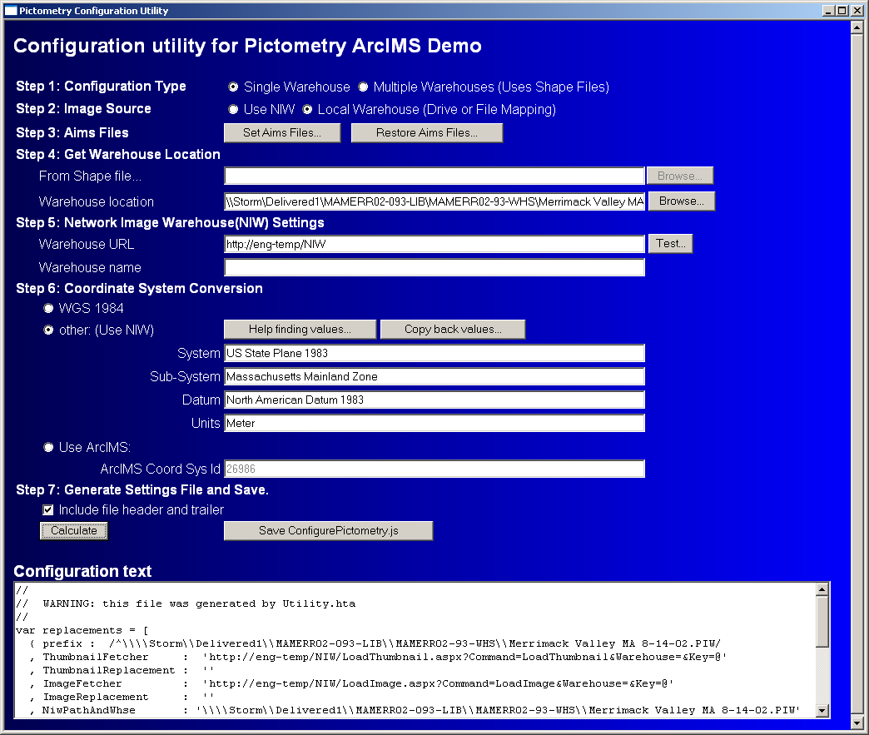

Configuration Type
Single warehouse configurations are simpler since they do not require the use of shape files. The input fields to set the warehouse location will become disabled.
Multiple warehouses may be used to access image data from different years, for example. In this case, shape files are needed to distinguish which warehouse to query. Each shape file can be used to create a new layer in the ArcIMS service. The active layer will be used to determine the warehouse location and retrieve images. The user will need to cut-and-paste the second configuration into the ConfigurePictometry.js file.

Image Source
Local warehouses may now be accessed directly through the active X control without the use of NIW. If you select local warehouses then the Warehouse Location field will be enabled to select the PIW file that corresponds to your image warehouse. You may select local or network mapped drives as well as UNC paths. For example: \\MyServer\ImageShare\MyCounty\MyCounty.piw is a valid path. If you are using NIW then fields in Step 5 are required.

Aims Files
These buttons will check the existing aims files for any changes. If there have not been any changes, then the utility can safely overwrite the ESRI files with the Pictometry modified files. If you have already customized your AimsClick.js and AimsCustom.js files then you will need to manually update these files yourself.

Warehouse location: (disabled for single warehouse configuration)
The warehouse location, in most cases, can be extracted from the shape file (.dbf) that was generated in Sec. 4.2 above. Simply enter the full path and file name of your shape file or use the “Browse” button to select the .DBF file. The warehouse location should get populated with a path. Please check to be sure this path is correct. Some warehouses may be at a higher or lower directory level. This field can be edited if you need to make any changes.
You may also browse directly to the warehouse folder using the “Browse” button.
If you are not using NIW and are accessing the warehouse directly then you will want to select the warehouse PIW file.

Warehouse URL:
Enter the URL of your network image warehouse. Use the "Test..." button to verify that you have the entry correct. When you press the button you should see the Network Image Warehouse login page. When you login you will be presented with a list of available warehouses. Be sure to enter the warehouse name exactly as it is listed in NIW. Once you have the warehouse name you can exit NIW.

Warehouse Name:
Enter the name of your warehouse just as you entered it on the Network Image Warehouse configuration page.

Coordinate system conversion:
Enter the coordinate system for your ArcIMS map. If you are using WGS 1984 then no conversion is necessary. If you select "other" and are using NIW then click the "Help finding values..." button. When you are done selecting your coordinate system, switch back to the "utility.hta" window click "Copy back values...” This will copy data back from the coordinate selection window. You can now exit the coordinate selection window. The third option is to Use ArcIMS. You will then need to enter the coordinate system id from the ESRI documentation

File header and trailer:
If you have just one image warehouse then you can check "Include file header and trailer". When checked, the “Save ConfigurePictometry.js” button will be enabled since the complete file can be generated. If you have more than one warehouse you can uncheck "Include file header and trailer" for the second configuration.

Click "Calculate" button after you have entered all your data. If you change any entries just press "Calculate" again.

If “Include file header and trailer” is checked then the “Save ConfigurePictometry.js” button will be enabled. Pressing this button will save the file. If “Include file header and trailer” is unchecked then you will need to manually edit the ConfigurePictometry.js file.
Select all the text in the "Configuration Text" window. Paste this data into a text editor with ConfigurePictometry.js open, and then save.

If you are using multiple warehouses then you should include the file headers and trailers and generate the ConfigurePictometry.js file. You can then create new configurations for each warehouse you need to access. Turn off headers and trailers and click Calculate.
Then cut and paste the new configuration into the existing ConfigurePictometry.js file.

Now exit "Utility.hta".

Note: if you run the Utility.hta program again most of the values will be restored from the existing ConfigurePictometry.js file. The exception is the Shape file path. This is due to the security of the control which accesses the file system. This is not needed to generate the file. It is only used to conveniently extract the warehouse location. You do not need to re-enter the shape file path.

License File

The license file must be placed in the website\htmlviewer\PictImsExample<version>\ directory. The file should be named License.txt. This file shall be provided by Pictometry. The image viewer control is licensed to a domain or domains. Therefore the license file must have site specific information. The utility :GetSiteInfo” will produce an encrypted string which can be inserted into a license file. The utility can also update the license file directly. The license must be re-validated by Pictometry before it can be used. To validate the license simply e-mail it back to Pictometry. A license will be sent back to you which will enable the image viewer and its tools.

Running the program.

The use the web-based ArcIms viewer, Point your internet browser to:
http://<machine Name>/website/htmlviewer/PictImsExample<version>

Client Configuration

Configure Internet Explorer
You will need to enable scripting and download of ActiveX controls. You must do this for the zone that your ArcIMS server is in. You may choose to make the ArcIMS server a "Trusted Site".

Warning: A complete discussion of Internet Explorer security is beyond the scope of this document. For more information about security visit the Microsoft web site. Here is a good starting place:
Working with Internet Explorer 6 Security Settings
http://www.microsoft.com/windows/ie/using/howto/security/settings.mspx

How to configure IE 6
a. Make ArcIMS server a trusted site (optional)
Tools->Internet Options
select "security" tab
select "trusted sites" icon
click "sites" button
type in the base url for the ArcIMS server (fill in your server & domain)
http://server , or
http://server.domain.com
uncheck "Require server verification (https:) for all sites in this zone
click "add"

b. Set security for trusted sites
Tools->Internet Options
select "security" tab
select "trusted sites" icon
select "custom level" button
change these settings:
ActiveX Controls and plug-ins
Download signed ActiveX controls
check enable or prompt

Run ActiveX control and plug-ins
check enable or prompt

Script ActiveX control marked safe for scripting
check enable or prompt

Scripting
Active scripting
check enable or prompt

